Independence Booklet

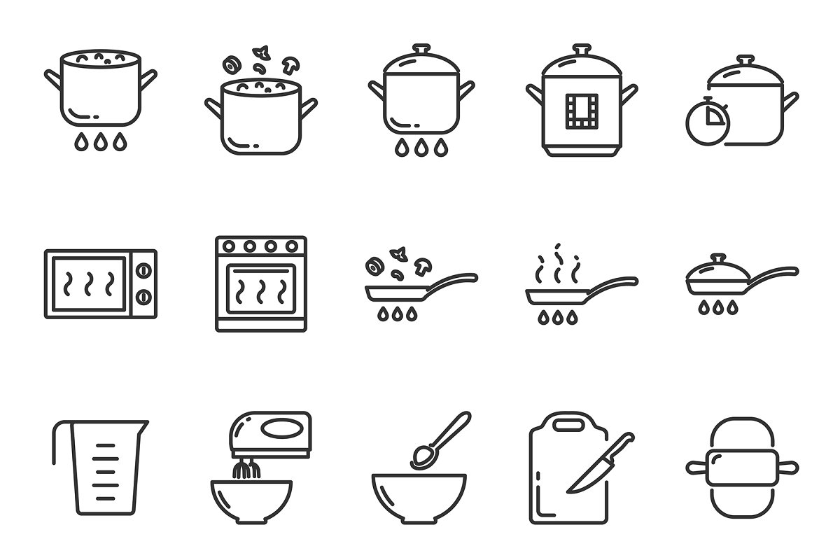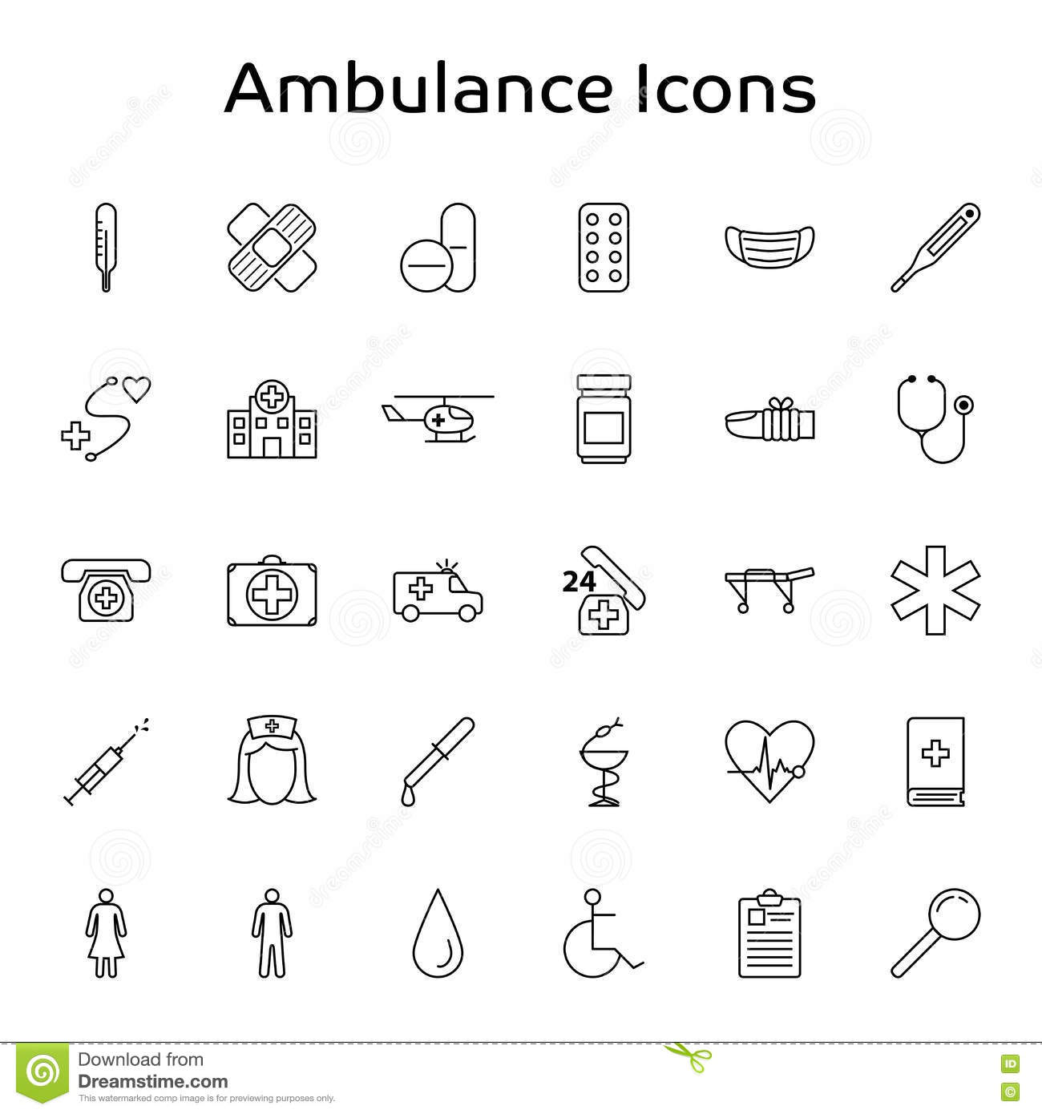

Name:



Name:

On Move In

**Key Contacts**

|  |  |  |
| --- | --- | --- |
| **Contact Name** | **Contact Details** | **Last/Upcoming appointment(s)** |
| Social Worker: |  |  |
| Leaving Care Worker: |  |  |
| Doctors: |  |  |
| Dentist: |  |  |
| Opticians: |  |  |
| Lawyer: |  |  |
| College/Employer: |  |  |

**Key Tasks**

|  |  |
| --- | --- |
| **Task** | **Date Completed** |
| Sign up meeting booked in. Interpreter booked if necessary. |  |
| Move in money requested received from leaving care/social worker. |  |
| Room and house ready and clean?  *Mattress purchased?* |  |
| Move in documents read, understood, signed and shared with young person  *Print and share anything signed* |  |
| Young person’s guide shared and discussed. |  |
| Move in shop completed with young person |  |
| Welcome pack given to young person |  |
| House tour with young person  *Specific attention paid to notice board and fire safety.* |  |
| Local area tour with young person |  |

Young Person’s Induction (first 2 weeks)

When a young person is 18 with refugee status

**Key Contacts**

Make sure they are up to date.

**Our Paperwork**

|  |  |  |
| --- | --- | --- |
| **Task** | **Date Completed** | **Review date** |
| Young person’s guide review  *Do you have any questions about what you’ve read?* |  |  |
| Shown Young Person’s section of website |  |  |
| Risk assessment complete |  |  |
| Readiness for adulthood assessment complete |  |  |
| Support plan actions complete |  |  |
| What’s on at the office explained |  |  |
| Emergency numbers given to young person |  |  |

**Health and Wellbeing**

|  |  |
| --- | --- |
| **Task** | **Date Completed** |
| Health registration complete (GP, Dentist & Optician)  *If young person wants to stay at previous provider note above along with last appointment* |  |

**Current Immigration status**

|  |  |
| --- | --- |
| Stage of immigration process |  |

**Finance and Money Management**

|  |  |
| --- | --- |
| **Task** | **Date Completed** |
| Bank account set up? |  |
| Where does your weekly money come from and how often? |  |
| Housing benefit application complete  (if relevant) |  |
| Council tax forms complete (if living in a flat) |  |
| Universal credit application complete  (if relevant) |  |

**Property management**

|  |  |
| --- | --- |
| **Task** | **Date completed** |
| All paperwork on notice board explained |  |
| Discussed with young person about anything else they would like in their bedroom |  |
| Stop tap, fuse box, smoke alarms etc. explained *(see appendix 1)* |  |
| Bins and recycling explained *(see appendix 2)* |  |
| Basic health and safety and fire safety explained *(see appendix 3)* |  |
| Housekeeping schedule and cleaning expectations explained (*see appendix 7)* |  |
| Basic food storage and hygiene explained *(see* *appendix 8)* |  |

**Travel, Community and Keeping Safe**

|  |  |
| --- | --- |
| **Task** | **Date completed** |
| Local area shown and explained *(see young person’s guide and appendix 9)* |  |
| Bus pass application complete? |  |
| What to do in an emergency explained inc emergency number, roles of emergency services etc. *(see appendix 6 and 10)* |  |

**Education, Employment and Training**

|  |  |
| --- | --- |
| Current education, employment status and location |  |

**Personal Development**

|  |  |
| --- | --- |
| **Task** | **Date completed** |
| Keeping appointments explained (see appendix 4) |  |
| Important documents and where to keep them explained *(see appendix 5)* |  |
| What to do if you receive a letter, phone call, text, or email that you do not understand explained |  |

**Key Contacts**

Make sure they are up to date above.

**Health and Wellbeing**

|  |  |
| --- | --- |
| **Task** | **Date Completed** |
| LAC nurse contacted for updates (under 18) |  |
| Dental appointment scheduled or attended |  |
| GP registration confirmed and how to make an appointment explained |  |
| Opticians’ appointment scheduled or attended |  |
| Sexual health nurse appointment scheduled or attended |  |
| Referral to mental health or addiction services completed (if necessary) |  |
| Gym pass applied for and received |  |

**Current Immigration status**

|  |  |
| --- | --- |
| Stage of immigration process |  |

|  |  |
| --- | --- |
| **Task** | **Date Completed** |
| Travel document application completed |  |

**Finance and Money management**

|  |  |
| --- | --- |
| **Task** | **Date Completed** |
| Benefits successfully set up |  |

**Property Management**

|  |  |
| --- | --- |
| **Task** | **Date completed** |
| Bins and recycling re explained *(see appendix 2)* |  |
| Basic health and safety and fire safety re explained *(see appendix 3)* |  |
| Housekeeping schedule and cleaning expectations re explained (*see appendix 7)* |  |
| Basic food storage and hygiene re explained *(see* *appendix 8)* |  |

When a young person is 18 with refugee status

Within 4 weeks of move in

**Travel, Community and Keeping Safe**

|  |  |
| --- | --- |
| **Task** | **Date completed** |
| What to do in an emergency re explained inc emergency number, roles of emergency services etc. *(see appendix 6 and 10)* |  |

**Education, Employment and Training**

|  |  |
| --- | --- |
| **Task** | **Date completed** |
| College application complete (if relevant) |  |
| Training courses explored (if relevant) |  |
| Other education courses explored (if relevant) |  |
| Volunteering opportunities explored (if relevant) |  |

**Personal Development**

|  |  |
| --- | --- |
| **Task** | **Date Completed** |
| Provisional licence applied for |  |
| National insurance number letter applied for *(if not known)* |  |
| Red cross find my family appointment booked *(if necessary)* |  |
| Hobbies and activities discussed |  |

**When young person is 18 with refugee status**

Complete all tasks highlighted in yellow.

|  |  |
| --- | --- |
| **Task** | **Date Completed** |
| Manchester move application completed |  |
| Band 1 application completed |  |
| Bidding explained and checked regularly |  |

3 Months after Move In

**Key Contacts**

Update above if necessary

**Our Paperwork**

|  |  |  |
| --- | --- | --- |
| **Task** | **Date Completed** | **Review date** |
| Risk assessment complete |  |  |
| Readiness for adulthood assessment complete |  |  |
| Support plan actions complete |  |  |

**Property Management**

|  |  |
| --- | --- |
| **Task** | **Date completed** |
| Bins and recycling re explained *(see appendix 2)* |  |
| Basic health and safety and fire safety re explained *(see appendix 3)* |  |
| Housekeeping schedule and cleaning expectations re explained (*see appendix 7)* |  |
| Basic food storage and hygiene re explained *(see* *appendix 8)* |  |

6 Months after Move In

**Key Contacts**

Update above if necessary

**Our Paperwork**

|  |  |  |
| --- | --- | --- |
| **Task** | **Date Completed** | **Review date** |
| Risk assessment complete |  |  |
| Readiness for adulthood assessment complete |  |  |
| Support plan actions complete |  |  |

**Property Management**

|  |  |
| --- | --- |
| **Task** | **Date completed** |
| Bins and recycling re explained *(see appendix 2)* |  |
| Basic health and safety and fire safety re explained *(see appendix 3)* |  |
| Housekeeping schedule and cleaning expectations re explained (*see appendix 7)* |  |
| Basic food storage and hygiene re explained *(see* *appendix 8)* |  |

6 Months after Move In

**Key Contacts**

Update above if necessary

**First Key Homes/Housing**

Risk assessment complete

Individual contingency plan complete

**Housekeeping**

Re-explain bins and recycling *(see appendix 2)*

**Support planning**

Review last targets, add them to table if not complete

Discussion around how the young person is feeling, how they are doing and what goals they want to achieve in the next 3 months. *Cover areas such as: health (mental and physical), education and employment, socialisation (friends, hobbies, interests), keeping safe, links to the community, enjoyment, and readiness for move on.*

Use this discussion to guide the young person to set some targets to work towards during the next 3 months *Make sure they are* ***S****pecific* ***M****easureable* ***A****chievable* ***R****ealistic* ***T****imely*

|  |  |  |  |  |
| --- | --- | --- | --- | --- |
| **Target** | **Steps to achieve** | **Who can help?** | **Time frame** | **Completed?** |
|  |  |  |  |  |
|  |  |  |  |  |

9 Months after Move In

1 Year after Move In

**Key Contacts**

Update above if necessary

**Our Paperwork**

|  |  |  |
| --- | --- | --- |
| **Task** | **Date Completed** | **Review date** |
| Risk assessment complete |  |  |
| Readiness for adulthood assessment complete |  |  |
| Support plan actions complete |  |  |

**Property Management**

|  |  |
| --- | --- |
| **Task** | **Date completed** |
| Bins and recycling re explained *(see appendix 2)* |  |
| Basic health and safety and fire safety re explained *(see appendix 3)* |  |
| Housekeeping schedule and cleaning expectations re explained (*see appendix 7)* |  |
| Basic food storage and hygiene re explained *(see* *appendix 8)* |  |

9 Months after Move In

**Key Contacts**

Update above if necessary

**Our Paperwork**

|  |  |  |
| --- | --- | --- |
| **Task** | **Date Completed** | **Review date** |
| Risk assessment complete |  |  |
| Readiness for adulthood assessment complete |  |  |
| Support plan actions complete |  |  |

**Property Management**

|  |  |
| --- | --- |
| **Task** | **Date completed** |
| Bins and recycling re explained *(see appendix 2)* |  |
| Basic health and safety and fire safety re explained *(see appendix 3)* |  |
| Housekeeping schedule and cleaning expectations re explained (*see appendix 7)* |  |
| Basic food storage and hygiene re explained *(see* *appendix 8)* |  |

12 Months after Move In

**Key Contacts**

Update above if necessary

**Our Paperwork**

|  |  |  |
| --- | --- | --- |
| **Task** | **Date Completed** | **Review date** |
| Risk assessment complete |  |  |
| Readiness for adulthood assessment complete |  |  |
| Support plan actions complete |  |  |

**Property Management**

|  |  |
| --- | --- |
| **Task** | **Date completed** |
| Bins and recycling re explained *(see appendix 2)* |  |
| Basic health and safety and fire safety re explained *(see appendix 3)* |  |
| Housekeeping schedule and cleaning expectations re explained (*see appendix 7)* |  |
| Basic food storage and hygiene re explained *(see* *appendix 8)* |  |

15 Months after Move In

**Key Contacts**

Update above if necessary

**Our Paperwork**

|  |  |  |
| --- | --- | --- |
| **Task** | **Date Completed** | **Review date** |
| Risk assessment complete |  |  |
| Readiness for adulthood assessment complete |  |  |
| Support plan actions complete |  |  |

**Property Management**

|  |  |
| --- | --- |
| **Task** | **Date completed** |
| Bins and recycling re explained *(see appendix 2)* |  |
| Basic health and safety and fire safety re explained *(see appendix 3)* |  |
| Housekeeping schedule and cleaning expectations re explained (*see appendix 7)* |  |
| Basic food storage and hygiene re explained *(see* *appendix 8)* |  |

18 Months after Move In

**Key Contacts**

Update above if necessary

**Our Paperwork**

|  |  |  |
| --- | --- | --- |
| **Task** | **Date Completed** | **Review date** |
| Risk assessment complete |  |  |
| Readiness for adulthood assessment complete |  |  |
| Support plan actions complete |  |  |

**Property Management**

|  |  |
| --- | --- |
| **Task** | **Date completed** |
| Bins and recycling re explained *(see appendix 2)* |  |
| Basic health and safety and fire safety re explained *(see appendix 3)* |  |
| Housekeeping schedule and cleaning expectations re explained (*see appendix 7)* |  |
| Basic food storage and hygiene re explained *(see* *appendix 8)* |  |

21 Months after Move In

**Key Contacts**

Update above if necessary

**Our Paperwork**

|  |  |  |
| --- | --- | --- |
| **Task** | **Date Completed** | **Review date** |
| Risk assessment complete |  |  |
| Readiness for adulthood assessment complete |  |  |
| Support plan actions complete |  |  |

**Property Management**

|  |  |
| --- | --- |
| **Task** | **Date completed** |
| Bins and recycling re explained *(see appendix 2)* |  |
| Basic health and safety and fire safety re explained *(see appendix 3)* |  |
| Housekeeping schedule and cleaning expectations re explained (*see appendix 7)* |  |
| Basic food storage and hygiene re explained *(see* *appendix 8)* |  |

24 Months after Move In

**Our Paperwork**

|  |  |
| --- | --- |
| **Task** | **Date Completed** |
| Relinquishment form completed and sent to leaving care worker |  |
| Void check completed and information shared with relevant people |  |

**Health and Wellbeing**

|  |  |
| --- | --- |
| **Task** | **Date Completed** |
| New GP, Dentist and Optician found and registered for? |  |

**Finance and Money management**

|  |  |
| --- | --- |
| **Task** | **Date Completed** |
| Housing benefit change of circumstances completed? |  |
| Universal credit change of circumstances completed? |  |
| Rent payments set up at new property |  |
| Council tax set up at new property, with care leavers exemption |  |
| Address updated at bank |  |

**Property Management**

|  |  |
| --- | --- |
| **Task** | **Date Completed** |
| Welfare provision applied for and delivered |  |
| Flooring and window coverings purchased and fitted |  |
| Bed and whitegoods purchased delivered and fitted |  |
| Gas and electricity account set up at new property |  |
| Turn on and test booked and completed at new property |  |
| Water account set up at new property |  |
| Explained who to contact for repairs and for support from Housing association |  |

On or Within 4 weeks of Move On

**Travel, Community and Keeping safe**

|  |  |
| --- | --- |
| **Task** | **Date Completed** |
| New community explored |  |

**Education, Employment and Training**

|  |  |
| --- | --- |
| **Task** | **Date completed** |
| Address updated at college/employer |  |

**Personal Development**

|  |  |
| --- | --- |
| **Task** | **Date Completed** |
| Address updated on provisional licence |  |
| Leaving gift given to young person |  |
|  |  |
|  |  |